## Curriculum Web Service Runbook

### Short Description

A website that is used to look up information about the course and class offered at CSUN

### Required Software

Amazon web services account (AWS)

-accessed via user credentials

-create a new account

Physical machine

-terraform

-AWS CLI

-Git

-ssh capabilities

Aws Controls

-Ansible

-MariaDB client

AWS webservers

-nginx

-php

-php-fpm

-php ldap

-php mbstring

-php-mycrypt

-php mysql

### Architecture Diagram

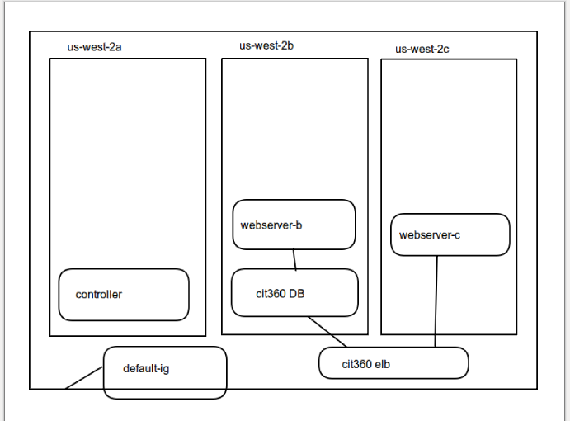

### Deployment

Installing git on the physical machine would be the first step in the assignment in order to get the base materials for the assignment. Secondly you will need to install the aws cli in order to edit your infastructure for your aws account of your local machine. After git and the aws cli are installed and paired up with the git account, installing terraform on the physical machine will allow you to start editing the code for the infrastructure. After the code is written out and the specific files needed are configured and set up in the appropriate directories you need to ssh into the instance. Once in the instance you need to move the ansible directory into your instance and install ansible so you’re able to run the playbooks. Edit your playbooks in order to correct any errors that are occurring and run them.

### Issues

**Title:** unable to ssh into instance

**Description:** unable to ssh into the instance with the short or long handed method

**Remediation Steps:** Kill the current instance and delete your key pair. Go into the aws consile and create a new key pair and save it to your ~/.ssh directory with the permissions 0400

chmod 0400 cit360.pem

create a file named config

Host

IdentityFile ~/.ssh/cit360.pem

User ec2-user

Hostname

PasswordAuthentication no

Enter the name of the instance after host and enter the public dns after host name. Add the path to the .pem key after identity file and save the config file. Give it permissions 0600 and try and ssh into the instanc e

chmod 0600 config

ssh bastion

